05d. Owner Tool
- Overview and Purpose
- Searching in the Owner Tool
- Data Fields in the Top Section
- Detailed Member Information (Bottom Section)

Overview and Purpose
We use the Owner Tool to confirm somebody's affiliation status, find information about the source of affiliation, and also to disable or enable somebody's fraud or owner status.

Searching in the Owner Tool
The default search option is "auto," which is used when searching for a specific email address. When searching by location ID, it is important to switch from "auto" to "Location ID" before clicking on "search."
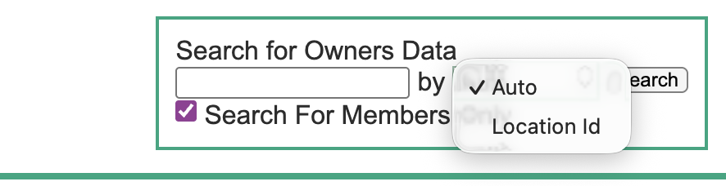

Data Fields in the Top Section
- Fraud Status: There are two possible statuses: "Enabled" or "Disabled." A owner's status shows as "Enabled" for all current and former representatives of the property. "Disabled" only applies to members who were found to have never been affiliated with a property or ceased to be affiliated at some point.
- Member: Shows the Username and the unique User ID of the member.
- Email: Shows the emails of all owners that registered for the property if you have searched for owner information by location ID. Note that some properties can have a lot of representatives listed.
- Property: This shows the full Location name and Location ID for the property.
- Source: Defines how someone became affiliated. Common scenarios include:
  - Owner Tis+number: Claimed owner status but didn't verify registration; considered a representative.
  - LR+number: Listing Request for a new property or update.
  - GetCode+number: Landed on an owner-associated page; unlikely to be a representative.
  - Owner Reg+number: Official representative registration; can show as former if disabled.
- Other Attributes: Captured data like fingerprints and IP addresses from the time of affiliation.
- Affiliation: The position selected by the owner during registration.
- Registration Status: Includes Disabled (affiliation removed), Verified (100% affiliated), and Registered but not verified (incomplete process). Note: Affiliation dates are found in the Location Center.
- Verification Method: Explains how the Owner was able to verify their registration.
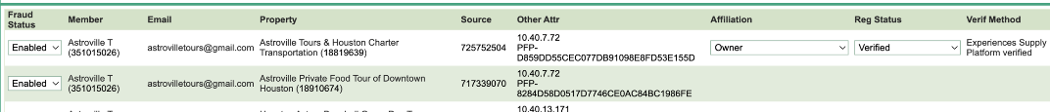

Detailed Member Information (Bottom Section)
- Main Panel (Captured Info): Displays Email, Actual name, Account Created date.
- Center Panel (Contributions): Shows DE Info, Num Reviews, and Num Forum Posts.
- Right Panel: Offers a "notes" option about the member (rarely used).
